Community Protection across different transmission intensities

Background
Long-lasting insecticidal nets (LLINs) have been the backbone of malaria vector control for more than two decades and are estimated to have averted a substantial proportion of malaria cases globally. Their effectiveness arises from a combination of direct personal protection—through physical barrier effects and insecticide-mediated deterrence or killing of mosquitoes—and indirect, community-level protection mediated through reductions in mosquito survival, density, and transmission intensity.
Evidence for community-level protection from insecticide-treated nets emerged early from large-scale trials, most notably from western Kenya, where reductions in malaria prevalence and child mortality were observed not only among net users but also among non-users living near households using nets. Subsequent empirical studies and modelling analyses have reinforced the concept that LLINs function partly as a public-good intervention, with indirect effects that may contribute substantially to population-level impact when coverage is high. Process-explicit simulations and transmission models have further suggested that, at high coverage, reductions in mosquito survival and infectiousness may prevent more transmission than personal protection alone
(The importance of considering c…, Quantifying the direct and indi…)
Despite this conceptual foundation, the magnitude and reliability of community protection from LLINs remain uncertain across epidemiological contexts. A growing body of work indicates that indirect effects are heterogeneous and sensitive to local transmission dynamics, intervention coverage, and vector ecology. Recent re-analyses of cluster-randomized trials of malaria interventions have demonstrated substantial spillover effects on incidence and prevalence among non-recipients, but also highlighted that such effects vary with spatial scale, baseline transmission intensity, and intervention mix
(Extension of efficacy range for…)
These findings raise important questions about the extent to which community protection can be assumed to scale uniformly with LLIN usage across different transmission settings. Transmission intensity, often summarized by the entomological inoculation rate (EIR), is likely to be a critical modifier of community-level effects. Modelling studies parameterized with entomological and epidemiological data have shown that baseline transmission intensity and intervention coverage exert stronger influence on population-level impact than insecticide resistance alone
(Effects of pyrethroid resistanc…)
At high transmission intensity, persistent exposure to infectious bites may constrain the degree to which reductions in mosquito survival translate into meaningful reductions in human infection prevalence, potentially leading to saturation of indirect effects even at high LLIN usage. At the same time, the mechanisms underpinning community protection are evolving. Widespread pyrethroid resistance and declining durability of nets under field conditions have reduced the historical effects of LLINs on mosquitoes, shifting the balance of benefit increasingly toward physical barrier effects and consistent population-level use. Recent syntheses argue that while LLINs remain epidemiologically valuable, their capacity to generate strong communal benefits through mosquito killing has weakened in many settings, particularly where resistance is intense and nets age rapidly
(The fabric of life what if mosq…, Strengthening long-lasting inse…)
Taken together, this raises a critical concern that while community protection is widely used as a justification for universal LLIN coverage, its dependence on transmission intensity and achievable coverage levels has not been systematically quantified across a broad EIR range. In particular, it remains unclear what levels of LLIN usage are required to achieve meaningful reductions in malaria prevalence among non-users, and whether such thresholds remain attainable in high-transmission settings.
In this study, we use a transmission-dynamic malaria model to quantify direct and indirect effects of LLIN usage across a wide range of transmission intensities. We compare malaria prevalence among LLIN users, non-users, and the overall population under varying usage levels, and explicitly estimate these effects as reductions in prevalence among non-users. We further identify LLIN usage thresholds required to achieve predefined levels of community-level prevalence reduction. By characterizing how indirect effects emerge, scale, and saturate across transmission settings, this analysis aims to clarify both the potential and the intrinsic limits of LLIN-mediated community protection.

Methods
Unwin et al.
- assuming a 3-year net distribution cycle
- For a population of 100,000 people, we simulate LLINs being used by 50% of the population at random from year 1 and show the all-age prevalence across the whole community falls from 60% to ~40% by year 2 for treated nets and 56% for untreated nets
- Specify net type used for simulation based on the parameterization
- Depending on the analyses both all-age prevalence and 6–59-month old prevalence are presented
- We briefly describe the model below focusing on how the effect of LLINs are incorporated
- The model is used to project how malaria prevalence may differ between users and non-users for different levels of malaria endemicity and LLIN use

Results
Vocabulary:
direct effect – prevalence reduction among users, relative to no-LLIN baseline
Indirect effect – prevalence reduction among non-users
Community effect – absolute difference in prevalence reduction between users and overall population
For a population of 10000 individuals, we simulated LLIN being used by 20, 40, 60, 70, 80 and 90% of the population at random from 2021 (year 1) to 2026 (year 6) and tracked the prevalence rates among both LLIN users and non-users across different transmission settings.
Across all transmission settings, a monotonic increase was observed in baseline malaria prevalence with entomological inoculation rate (EIR). At low transmission intensity (EIR $=8-16$), prevalence declined rapidly over time under increasing LLIN usage, whereas at moderate to high transmission intensity (EIR $≥32$), declines were slower and residual prevalence remained substantial even at high coverage levels (Figure 1). In the absence of LLIN usage, prevalence remained high and relatively stable over time across all EIRs. Temporal trends for two LLIN campaigns (2021 and 2024) further indicated that the impact of LLINs accumulated gradually over successive years, with the steepest declines observed shortly after intervention deployment in low-EIR settings, and more protracted reductions in higher-EIR settings.
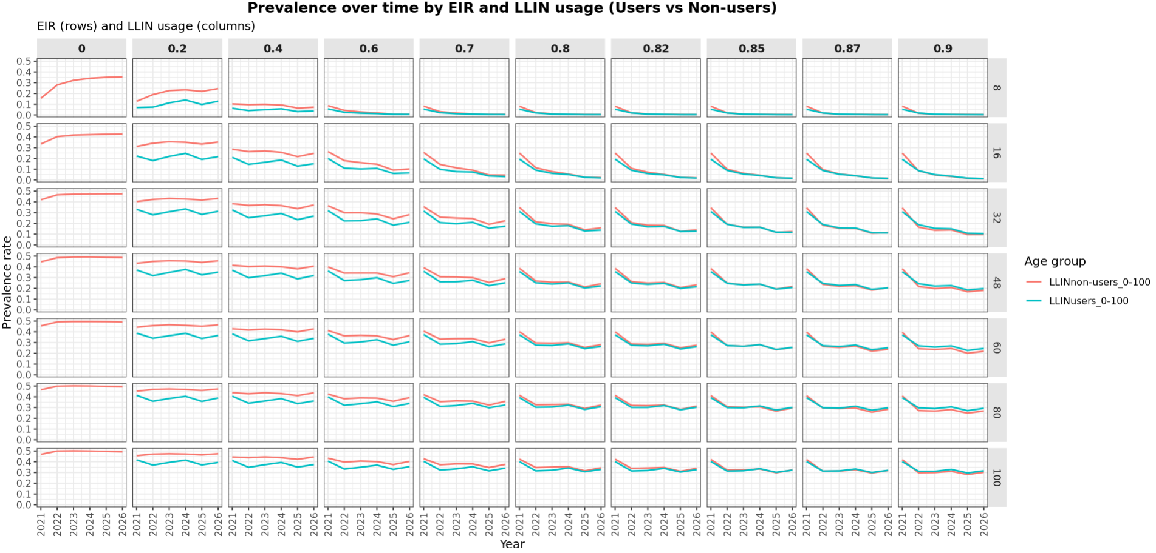
Figure 1: Temporal trends in malaria prevalence among LLIN users and non-users across transmission intensities. Malaria prevalence from 2021–2026 is shown for LLIN users and non-users under varying LLIN usage levels and entomological inoculation rates (EIR = 8–100). Rows correspond to increasing transmission intensity, and columns correspond to increasing LLIN usage. Representative transmission intensities (EIR = 8, 48, 100) are shown; results for all EIRs are provided in Supplementary Figures. Across all EIRs, prevalence is consistently lower among LLIN users than non-users, reflecting direct protection. Prevalence among non-users also declines with increasing LLIN usage, indicating community-level protection, but this effect weakens as transmission intensity increases

Based on the assumptions of the model, at all EIR levels and LLIN usage levels, all-age / U5 malaria prevalence was consistently lower among LLIN users compared to non-users, reflecting the direct protective effect of LLIN use (Figure 2). However, prevalence among non-users also declined as LLIN usage increased, indicating the presence of indirect (community-level) effect of LLIN use. The magnitude of this indirect effect varied substantially by transmission intensity. At low EIR ($8-16$), non-users experienced marked reductions in prevalence even at relatively low LLIN usage levels. In contrast, at higher EIRs ($≥60$), reductions among non-users were modest and only became apparent at high LLIN usage levels.
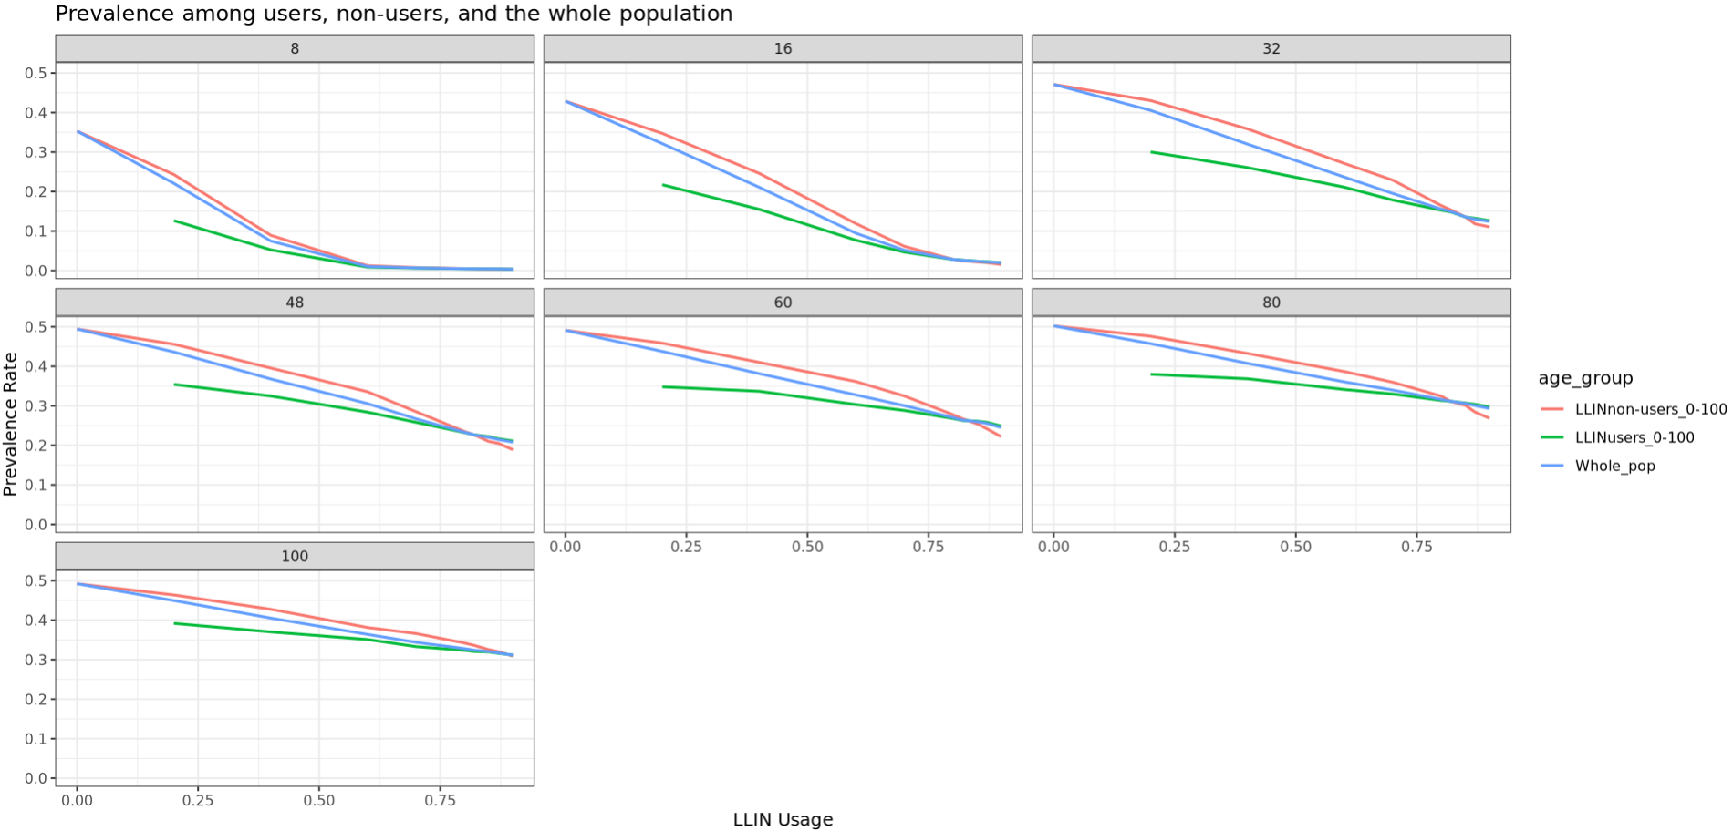
Figure 2: Malaria prevalence among LLIN users, non-users, and the overall population as a function of LLIN usage. Mean malaria prevalence is shown as a function of LLIN usage for LLIN users, non-users, and the whole population across representative transmission intensities. LLIN users consistently experience the lowest prevalence, while non-users benefit indirectly as LLIN usage increases. Whole-population prevalence closely tracks prevalence among non-users, indicating that indirect effects contribute substantially to population-level impact.

Direct and indirect effects of LLINs were quantified as reductions in prevalence among users and non-users respectively, relative to the no-LLIN baseline. Community effect was also quantified as the difference in prevalence reduction between LLIN users and the overall population.
Across all EIRs, percent reductions in prevalence increased monotonically with LLIN usage but exhibited strong non-linearities. Parallel, but smaller reductions were observed in both non-user and overall populations compared to the user population (Figure 3). At low transmission intensity (EIR = $8-16$), indirect effects emerged rapidly, with LLIN usage below 30% sufficient to achieve prevalence reductions of $10-20\%$ among non-users. At moderate transmission intensity (EIR = $32-48$), higher LLIN usage (approximately $40-60\%$) was required to achieve comparable reductions. At high transmission intensity (EIR $≥60$), even very high LLIN usage ($>80\%$) resulted in only moderate reductions among non-users. These results indicate that the strength of community protection from LLINs declines sharply with increasing transmission intensity, and that indirect effects saturate at lower levels of LLIN usage in high-EIR settings.
Reductions in overall-population prevalence closely tracked reductions observed among non-users rather than users (Figure 3). This pattern indicates that indirect effects contributed substantially to overall population-level impact, particularly in low- and moderate-EIR settings. In low-EIR settings, whole-population prevalence declined steeply with increasing LLIN usage, reflecting both strong direct protection and substantial community effects. In contrast, in high-EIR settings, whole-population prevalence declined more gradually and remained high even at near-universal LLIN usage, consistent with constrained community protection.

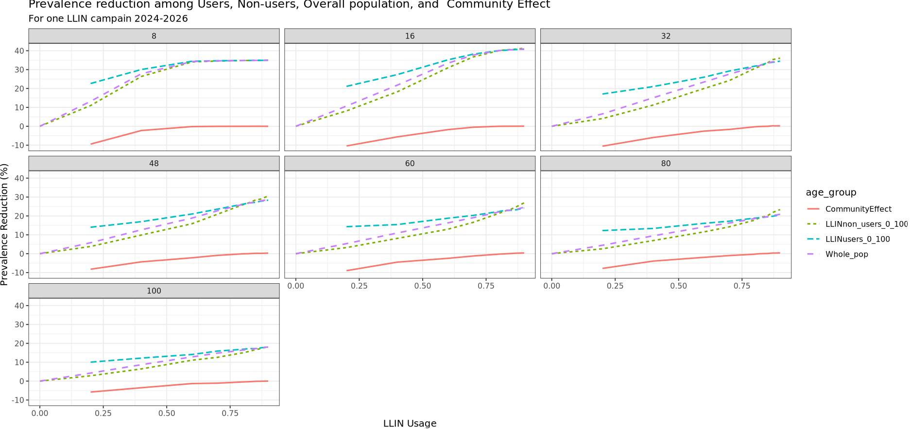
Figure 3: Prevalence reduction among LLIN users, non-users, and the overall population across LLIN usage levels. Percentage reduction in malaria prevalence relative to the no-LLIN baseline is shown for LLIN users, non-users, and the overall population across increasing LLIN usage. Community protection, measured as prevalence reduction among non-users, increases non-linearly with LLIN usage and is strongest at low transmission intensity. At high transmission intensity, community-level reductions remain modest even at high LLIN usage.
Threshold analyses revealed a strong, monotonic relationship between EIR and the LLIN usage required to achieve predefined reductions in prevalence among non-users (Figure 4 and Figure 5). To achieve a 10% reduction in prevalence among non-users, required LLIN usage increased from approximately 20% at EIR 8 to over 50% at EIR 100. Achieving a 20% reduction required substantially higher coverage, ranging from approximately 30% at EIR 8 to 80–90% at EIR ≥80. These findings demonstrate that community protection targets that are readily achievable in low-transmission settings may be infeasible in high-transmission settings without unrealistically high LLIN usage.
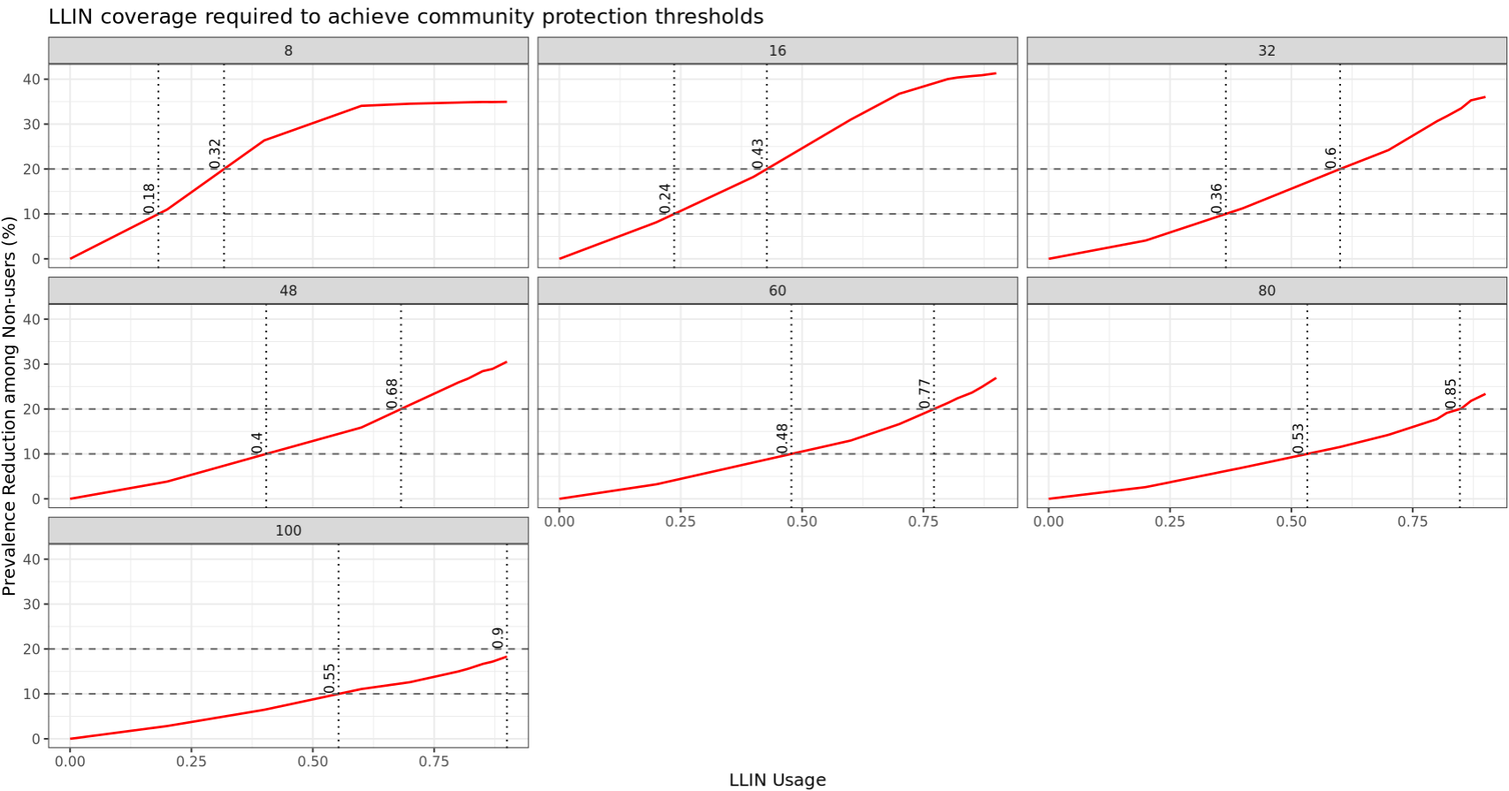
Figure 4: LLIN usage required to achieve community-level prevalence reduction thresholds.
The relationship between LLIN usage and prevalence reduction among non-users is shown for each transmission intensity. Horizontal dashed lines indicate 10% and 20% prevalence reduction thresholds, and vertical dotted lines indicate the LLIN usage required to achieve these thresholds. Required LLIN usage increases monotonically with transmission intensity, reaching near-universal coverage levels at high EIR.
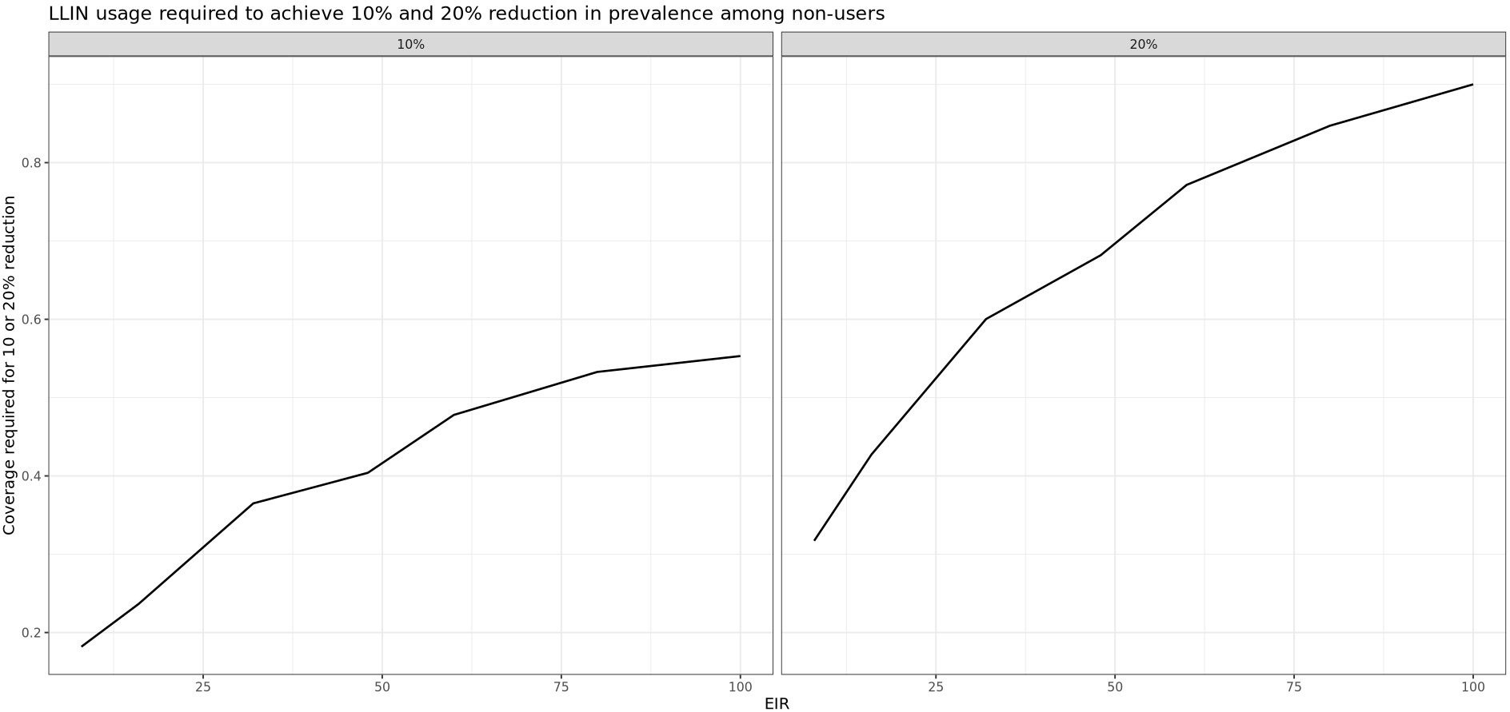
Figure 5: (supplementary?)

Discussion

Conclusion

References

